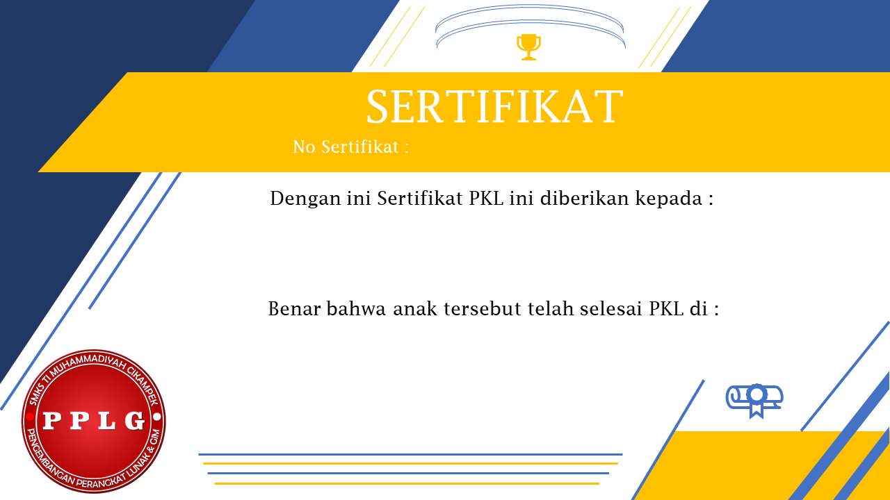

008

M. Ryan Handhika Susanto

PT. Lab Internasional

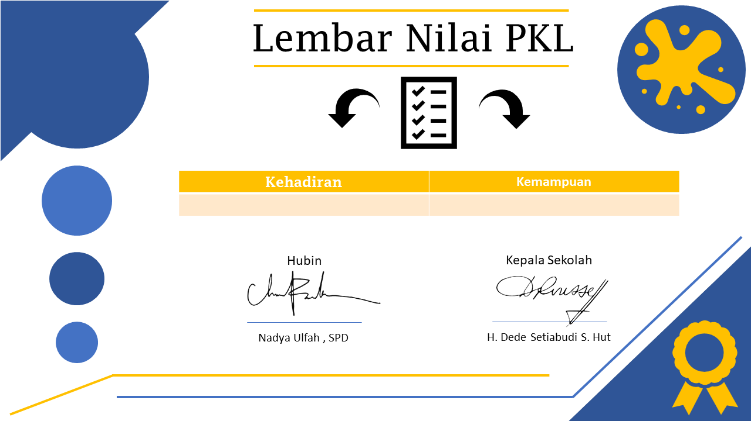

98 99